NAME:DIVYA.M

REG NO:727722EUIT504

SOFTWARE TESTING CC2

YATRA:

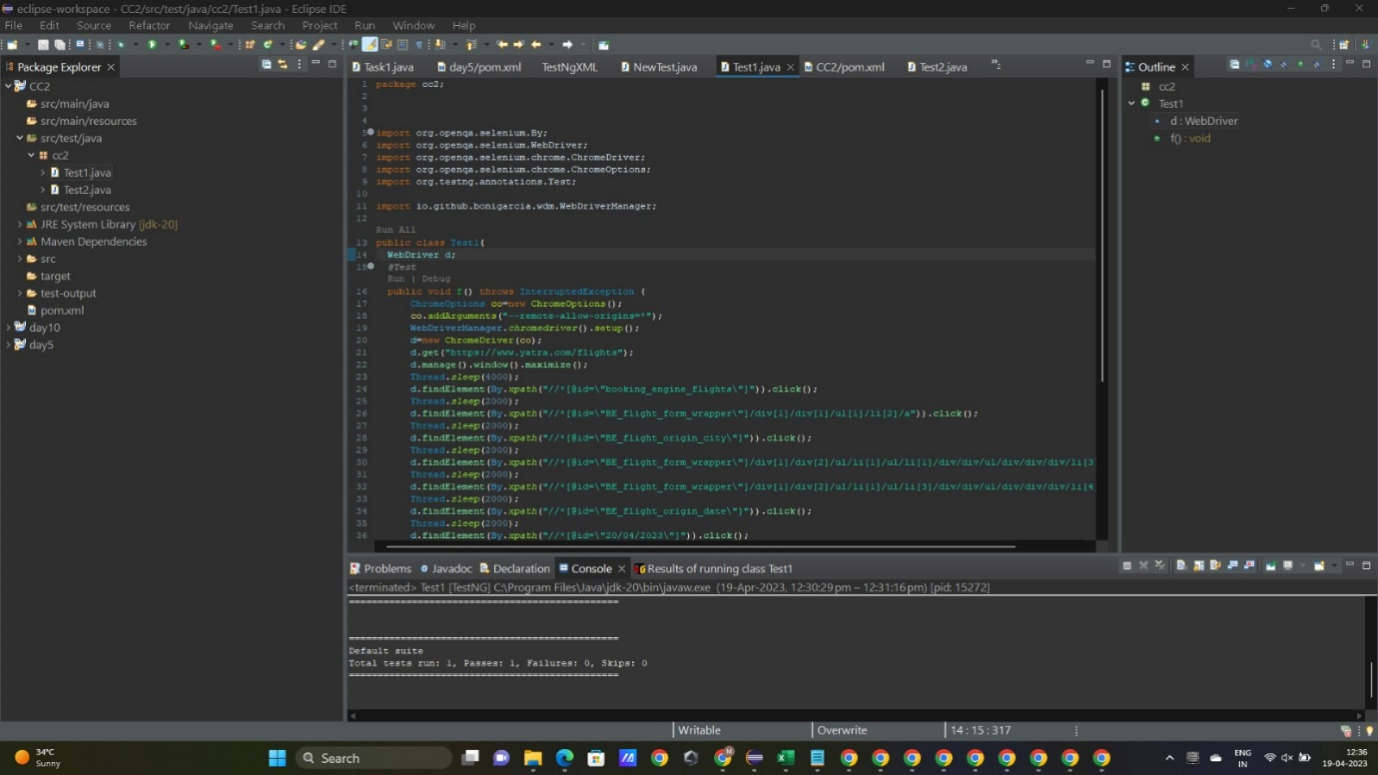



OUTPUT:

